Chương 4: Karnaugh-maps:

\* Sử dụng Karnaugh maps rút gọn biểu thức với 3 bit.

The answers:

3.1

1. F(x,y,z) = wps(0,2,4,5)= x’z’ + xy’

|  |  |  |  |  |
| --- | --- | --- | --- | --- |
| X YZ | 00 | 01 | 11 | 10 |
| 0 | 1 |  |  | 1 |
| 1 | 1 | 1 |  |  |

1. F(x,y,z) = (0,2,4,5,6) = z’ + xy’

|  |  |  |  |  |
| --- | --- | --- | --- | --- |
| X YZ | 00 | 01 | 11 | 10 |
| 0 | 1 |  |  | 1 |
| 1 | 1 | 1 |  | 1 |

1. F(x,y,z) = (0,1,2,3,5)= x’ + y’z

|  |  |  |  |  |
| --- | --- | --- | --- | --- |
| X YZ | 00 | 01 | 11 | 10 |
| 0 | 1 | 1 | 1 | 1 |
| 1 |  | 1 |  |  |

1. F(x,y,z) = (1,2,3,7)=x’z+x’y+yz

|  |  |  |  |  |
| --- | --- | --- | --- | --- |
| X YZ | 00 | 01 | 11 | 10 |
| 0 |  | 1 | 1 | 1 |
| 1 |  |  | 1 |  |

3.2

1. ( F(x,y,z) = IMG_256(0,1,5,7)=x’y’ + xz

|  |  |  |  |  |
| --- | --- | --- | --- | --- |
| X YZ | 00 | 01 | 11 | 10 |
| 0 | 1 | 1 |  |  |
| 1 |  | 1 | 1 |  |

1. F(x,y,z) = IMG_256(1,2,3,6,7)=y+x’z

|  |  |  |  |  |
| --- | --- | --- | --- | --- |
| X YZ | 00 | 01 | 11 | 10 |
| 0 |  | 1 | 1 | 1 |
| 1 |  |  | 1 | 1 |

1. F(x,y,z) = IMG_256(2,3,4,5)= x’y + xy’

|  |  |  |  |  |
| --- | --- | --- | --- | --- |
| X YZ | 00 | 01 | 11 | 10 |
| 0 |  |  | 1 | 1 |
| 1 | 1 | 1 |  |  |

1. F(x,y,z) = IMG_256(1,2,3,5,6,7)= z+y

|  |  |  |  |  |
| --- | --- | --- | --- | --- |
| X YZ | 00 | 01 | 11 | 10 |
| 0 |  | 1 | 1 | 1 |
| 1 |  | 1 | 1 | 1 |

1. F(x,y,z) = IMG_256(0,2,4,6)= x’y’ + xz’

|  |  |  |  |  |
| --- | --- | --- | --- | --- |
| X YZ | 00 | 01 | 11 | 10 |
| 0 | 1 | 1 |  |  |
| 1 | 1 |  |  | 1 |

1. F(x,y,z) = IMG_256(3,4,5,6,7)= x+yz

|  |  |  |  |  |
| --- | --- | --- | --- | --- |
| X YZ | 00 | 01 | 11 | 10 |
| 0 |  |  | 1 |  |
| 1 | 1 | 1 | 1 | 1 |

3.3

1. xy+x’y’z’+x’yz’

= xyz+xyz’+x’y’z’+x’yz’= x’z’+xy

|  |  |  |  |  |
| --- | --- | --- | --- | --- |
| X YZ | 00 | 01 | 11 | 10 |
| 0 | 1 |  |  | 1 |
| 1 |  |  | 1 | 1 |

1. x’y’+yz+x’yz’

= x’y’z+x’y’z’+xyz+x’yz+x’yz’= z+x’y’

|  |  |  |  |  |
| --- | --- | --- | --- | --- |
| X YZ | 00 | 01 | 11 | 10 |
| 0 | 1 | 1 | 1 |  |
| 1 |  | 1 | 1 |  |

1. xy’+yz’+y’z’

= x’yz+x’yz’+xyz’+xy’z’+x’y’z’= y’z’+xy’+xz’+xyz

|  |  |  |  |  |
| --- | --- | --- | --- | --- |
| X YZ | 00 | 01 | 11 | 10 |
| 0 | 1 |  | 1 |  |
| 1 | 1 | 1 |  | 1 |

1. X’yz+xy’z’+xy’z = xy’ + x’yz

|  |  |  |  |  |
| --- | --- | --- | --- | --- |
| X YZ | 00 | 01 | 11 | 10 |
| 0 |  |  | 1 |  |
| 1 | 1 | 1 |  |  |

3.4

1. F(x,y,z)= IMG_256(2,3,6,7)=x’z+xy

|  |  |  |  |  |
| --- | --- | --- | --- | --- |
| X YZ | 00 | 01 | 11 | 10 |
| 0 |  | 1 | 1 |  |
| 1 |  |  | 1 | 1 |

1. F(A,B,C,D)=(4,6,7,15)=A’BD’+BCD

|  |  |  |  |  |
| --- | --- | --- | --- | --- |
| CD AB | 00 | 01 | 11 | 10 |
| 00 |  | 1 |  |  |
| 01 |  |  |  |  |
| 11 |  | 1 | 1 |  |
| 10 |  | 1 |  |  |

1. F(A,B,C,D)=(3,7,11,13,14,15)= CD+ABD+ABC

|  |  |  |  |  |
| --- | --- | --- | --- | --- |
| CD AB | 00 | 01 | 11 | 10 |
| 00 |  |  |  |  |
| 01 |  |  | 1 |  |
| 11 | 1 | 1 | 1 | 1 |
| 10 |  |  | 1 |  |

1. F (w,x,y,z)=(2,3,12,13,14,15)=wx+w’x’y

|  |  |  |  |  |
| --- | --- | --- | --- | --- |
| yz wx | 00 | 01 | 11 | 10 |
| 00 |  |  | 1 |  |
| 01 |  |  | 1 |  |
| 11 | 1 |  | 1 |  |
| 10 | 1 |  | 1 |  |

1. F (w,x,y,z)=(11,12,13,14,15)=WX+WYZ

|  |  |  |  |  |
| --- | --- | --- | --- | --- |
| YZ WX | 00 | 01 | 11 | 10 |
| 00 |  |  | 1 |  |
| 01 |  |  | 1 |  |
| 11 |  |  | 1 | 1 |
| 10 |  |  | 1 |  |

1. F (w,x,y,z)=IMG_256(8,10,12,13,14)=WZ’+WXY’

|  |  |  |  |  |
| --- | --- | --- | --- | --- |
| YZ WX | 00 | 01 | 11 | 10 |
| 00 |  |  | 1 | 1 |
| 01 |  |  | 1 |  |
| 11 |  |  |  |  |
| 10 |  |  | 1 | 1 |

3.5

1. F (w,x,y,z)=IMG_256(1,4,5,6,12,14,15)= xz’+w’y’z+wxy

|  |  |  |  |  |
| --- | --- | --- | --- | --- |
| YZ WX | 00 | 01 | 11 | 10 |
| 00 |  | 1 | 1 |  |
| 01 | 1 | 1 |  |  |
| 11 |  |  | 1 |  |
| 10 |  | 1 | 1 |  |

1. F (A,B,C,D)=IMG_256(2,3,6,7,12,13,14)= a’c+abc’+bcd’

|  |  |  |  |  |
| --- | --- | --- | --- | --- |
| CD AB | 00 | 01 | 11 | 10 |
| 00 |  |  | 1 |  |
| 01 |  |  | 1 |  |
| 11 | 1 | 1 |  |  |
| 10 | 1 | 1 | 1 |  |

1. F (w,x,y,z)=IMG_256(1,3,4,5,6,7,9,11,13,15)= z+w’x

|  |  |  |  |  |
| --- | --- | --- | --- | --- |
| YZ WX | 00 | 01 | 11 | 10 |
| 00 |  | 1 |  |  |
| 01 | 1 | 1 | 1 | 1 |
| 11 | 1 | 1 | 1 | 1 |
| 10 |  | 1 |  |  |

1. F (A,B,C,D)=IMG_256(0,2,4,5,6,7,8,10,13,15)= b’d’+a’b+bd

|  |  |  |  |  |
| --- | --- | --- | --- | --- |
| CD AB | 00 | 01 | 11 | 10 |
| 00 | 1 | 1 |  | 1 |
| 01 |  | 1 | 1 |  |
| 11 |  | 1 | 1 |  |
| 10 | 1 | 1 |  | 1 |

3.6

1. a’b’c’d’+ac’d’+b’cd’+a’bcd+bc’d

= a’b’c’d’ + abc’d’ + ab’c’d’+ab’cd’+a’b’cd’ + a’bcd + abc’d+a’bc’d

= b’d’+abc’+a’bd

|  |  |  |  |  |
| --- | --- | --- | --- | --- |
| CD AB | 00 | 01 | 11 | 10 |
| 00 | 1 |  | 1 | 1 |
| 01 |  | 1 | 1 |  |
| 11 |  | 1 |  |  |
| 10 | 1 |  |  | 1 |

1. X’z+w’xy’+w(x’y+xy’)

= wx’yz+wx’y’z+w’x’yz+w’x’y’z+w’xy’z+wx’yz+wx’yz’+wxy’z+wxy’z’

= y’z+w’x’y’+w’x’z+wxy’+wx’y

|  |  |  |  |  |
| --- | --- | --- | --- | --- |
| YZ WX | 00 | 01 | 11 | 10 |
| 00 | 1 |  | 1 |  |
| 01 | 1 | 1 | 1 | 1 |
| 11 | 1 |  |  | 1 |
| 10 |  |  |  | 1 |

1. A’B’C’D+AB’D+A’BC’+ABCD + AB’C

= A’B’C’D + AB’CD+AB’C’D+A’BC’D+A’BC’D’+ABCD+AB’CD’

=A’BC’+B’C’D+ACD+AB’C

|  |  |  |  |  |
| --- | --- | --- | --- | --- |
| CD AB | 00 | 01 | 11 | 10 |
| 00 |  | 1 |  |  |
| 01 | 1 | 1 |  | 1 |
| 11 |  |  | 1 | 1 |
| 10 |  |  |  | 1 |

1. A’B’C’D’ + BC’D + A’C’D + A’BCD + ACD’

= A’B’C’D’ + ABC’D+A’BC’D+A’B’C’D+A’BCD+ABCD’+AB’CD’

=A’B’C’+A’BD+BC’D+ACD’

|  |  |  |  |  |
| --- | --- | --- | --- | --- |
| CD AB | 00 | 01 | 11 | 10 |
| 00 | 1 |  |  |  |
| 01 | 1 | 1 | 1 |  |
| 11 |  | 1 |  |  |
| 10 |  |  | 1 | 1 |

\*Rút gọn biểu thức

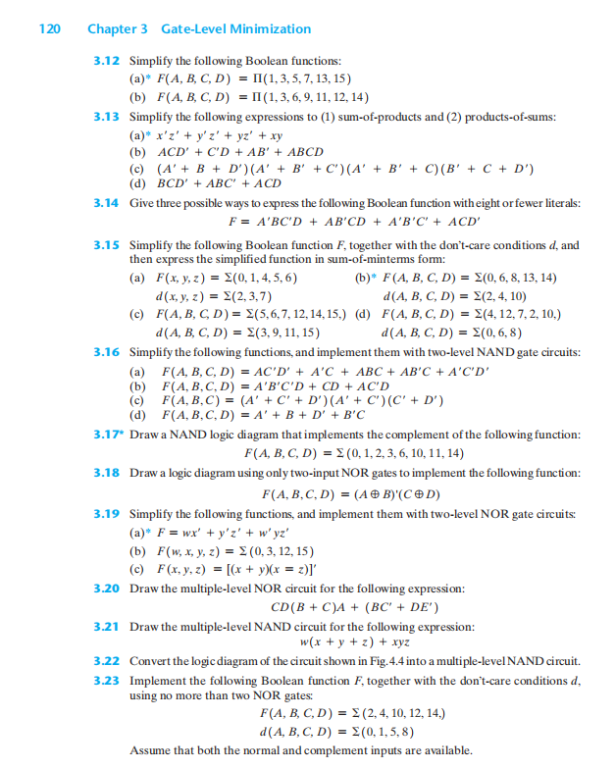



\* Sử dụng Karnaugh maps rút gọn biểu thức với 4 bit.

**3.7** Simplify the following Boolean expressions, using four-variable maps:

(a) w’z + xz + x’y + wx’z

(b) AD’ + B’C’D + BCD’ + BC’D

(c) AB’C + B’C’D’ + BCD + ACD’ + A’B’C + A’BC’D

(d) wxy + xz + wx’z + w’x

\* Từ F suy ra minterms và vẽ karnaugh maps

**3.8** Find the minterms of the following Boolean expressions by first plotting each function in a map:

(a) xy + yz + xy’z

(b) C’D + ABC’ + ABD’ + A’B’D

(c) wyz + w’x’ + wxz’

(d) A’B + A’CD + B’CD + BC’D’

\* Từ F tìm PIs và tìm EPIs:

**3.9** Find all the prime implicants for the following Boolean functions, and determine which are essential:

(a) F (w, x, y, z) = ∑ (0, 2, 4, 5, 6, 7, 8, 10, 13, 15)

(b) F (A, B, C, D) = ∑ (0, 2, 3, 5, 7, 8, 10, 11, 14, 15)

(c) F (A, B, C, D) = ∑ (2, 3, 4, 5, 6, 7, 9, 11, 12, 13)

(d) F(w, x, y, z) = ∑ (1, 3, 6, 7, 8, 9, 12, 13, 14, 15)

(e) F(A, B, C, D) =∑ (0, 1, 2, 5, 7, 8, 9, 10, 13, 15)

(f) F(w, x, y, z) = ∑(0, 1, 2, 5, 7, 8, 10, 15)

\* Rút gọn biểu thức F và tìm EPIs:

**3.10** Simplify the following Boolean functions by first finding the essential prime implicants:

(a) F(w, x, y, z) = ∑(0, 2, 5, 7, 8, 10, 12, 13, 14, 15)

(b) F(A, B, C, D) = ∑ (0, 2, 3, 5, 7, 8, 10, 11, 14, 15)

(c) F(A, B, C, D) = ∑ (1, 3, 4, 5, 10, 11, 12, 13, 14, 15)

(d) F(w, x, y, z) = ∑(0, 1, 4, 5, 6, 7, 9, 11, 14, 15)

(e) F(A, B, C, D) = ∑(0, 1, 3, 7, 8, 9, 10, 13, 15)

(f) F(w, x, y, z) = ∑(0, 1, 2, 4, 5, 6, 7, 10, 15)

Chuyển từ F thành SOP và rút gọn chúng:

**3.11** Convert the following Boolean function from a sum-of-products form to a simplified product-of-sums form.

F(x, y, z) = ∑(0, 1, 2, 5, 8, 10,

Chương 3: Logic Gates and Circuits

\* Sử dụng các LOGIC GATES vẽ sơ đồ và tìm biểu thức rút gọn, tìm Karnaught maps

**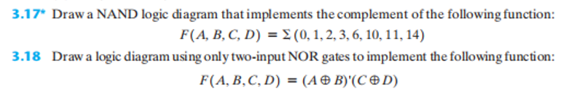**

**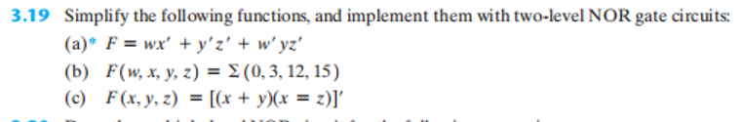**

****



Chương 2: BOOLEAN ALGEBRA

\*Định Lý Demorgan và vẽ mạch

**2.6** Draw logic diagrams of the circuits that implement the original and simplified expressions in Problem 2.3.

**2.7** Draw logic diagrams of the circuits that implement the original and simplified expressions in Problem 2.4.

**2.8** Find the complement of F = wx + yz; then show that FF’ = 0 and F + F’ = 1.

**2.9** Find the complement of the following expressions:

(a) xy’ + x’y

(b) (a + c).(a + b’).(a’ + b + c’)

(c) z + z’(v’w + xy)

**2.10** Given the Boolean functions F1 and F2 , show that

(a) The Boolean function E = F1 + F2 contains the sum of the minterms of F1 and F2.

(b) The Boolean function G = F1F2 contains only the minterms that are common to F1 and F2.



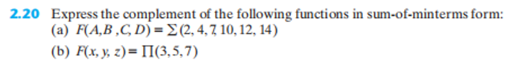

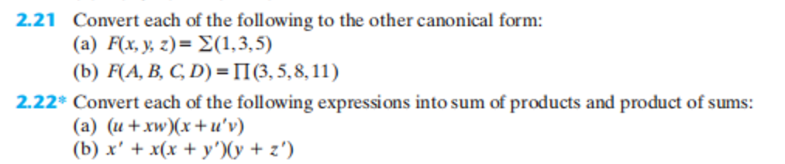

2.16)The logical sum off all minterms of a Boolean function of n variables is 1.

a)Prove the previou statement for n = 3

b) Suggest a procedure for a general proof

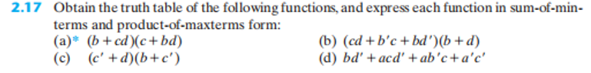

**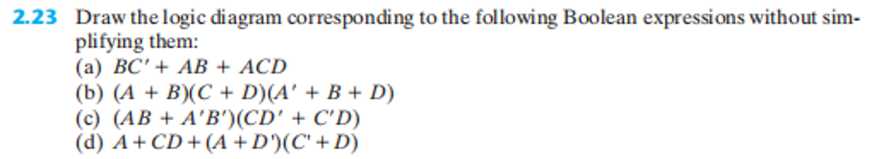**

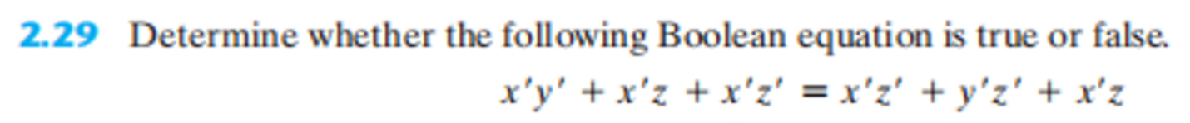

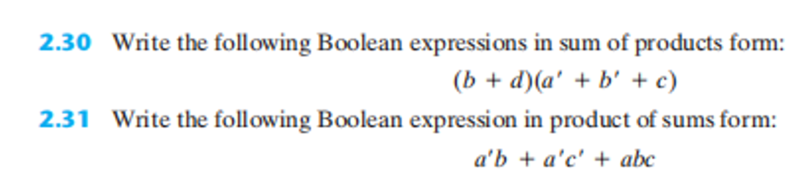

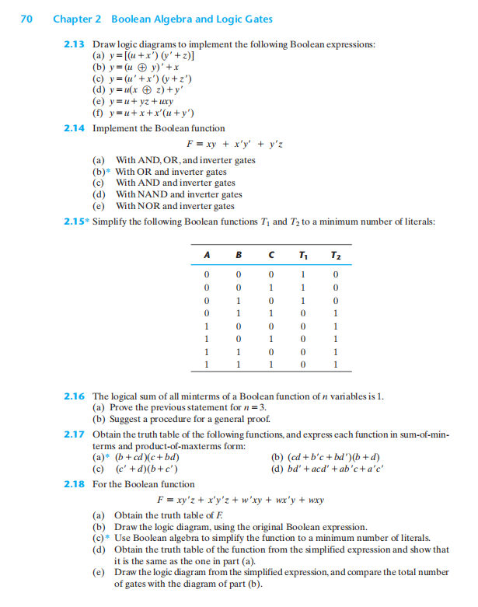

\*Cho mạch logic tìm biểu thức F



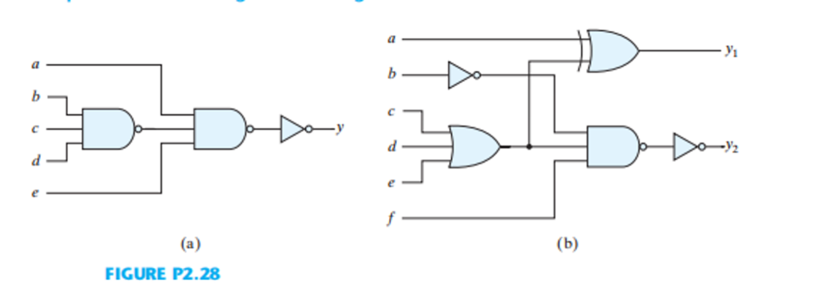

\*Cho bảng chân trị tìm F

